(Recommended Length of 20 pages)
COMP 1828 - Designing, developing and testing solutions for the London Underground system

TASK 1
Operational Station Status System
[20 marks]
You may retain only those headings in bold to conserve space in the report.

(1a)
Manual versus Code-Based Execution of a Data Organisation Strategy
- Data Structure Selection: A Chained Hash Table (from Introduction to Algorithms, 4th Edition – Cormen et al., Chapter 11) was selected to manage the daily list of operational London Underground stations.
Justification:
The chained hash table supports:
• Insertion O(1) average time
• Deletion O(1) average time
• Membership check O(1) average time

Stations are assigned to “buckets” by a hash function; collisions are resolved through linked lists (chaining).
This provides excellent performance for networks with constant updates to operational status.
Other structures (e.g., arrays O(n) or balanced trees O(log n)) are slower for frequent lookups.

- Create a Simple Dataset:
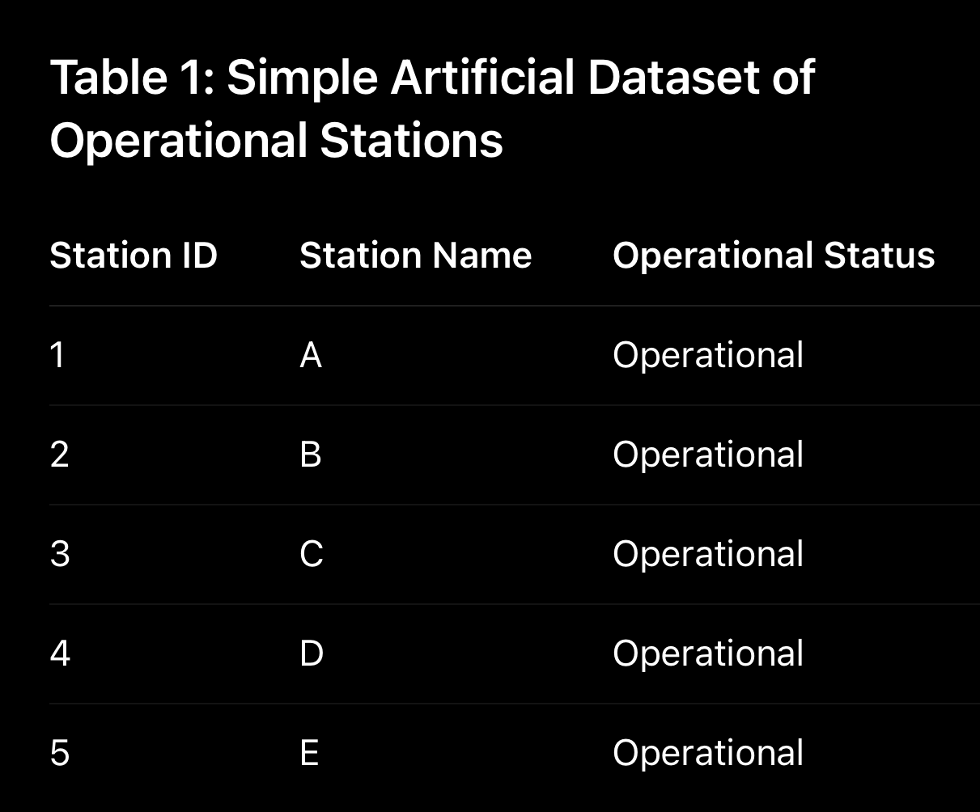
- Manual Application: Each station was inserted sequentially into an 8-bucket hash table.
The internal state after each insertion is shown below.
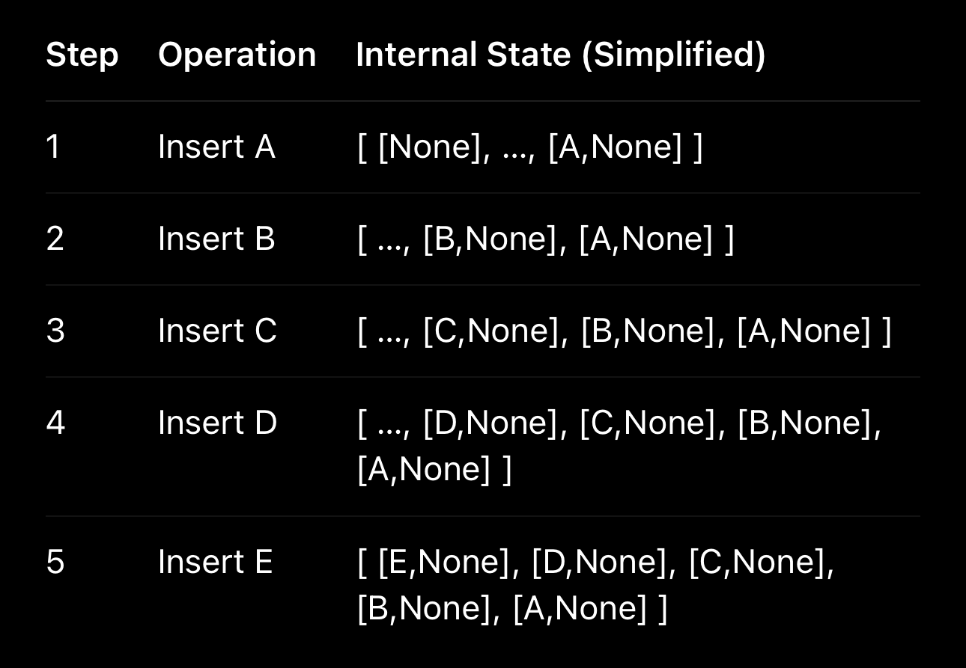
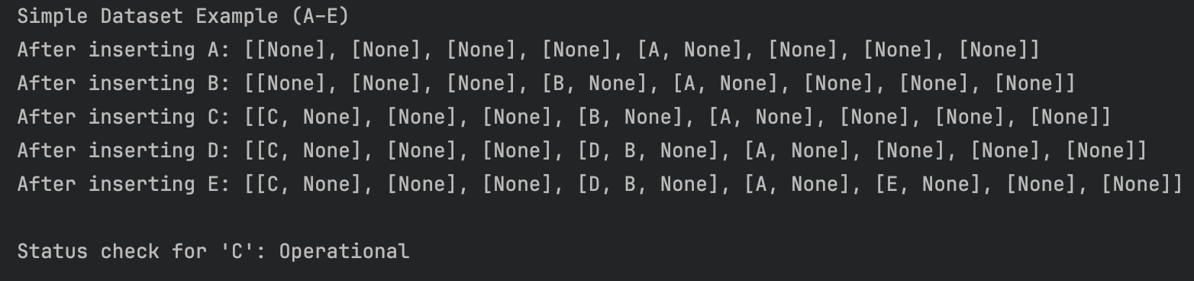
- Code Implementation and Verification:
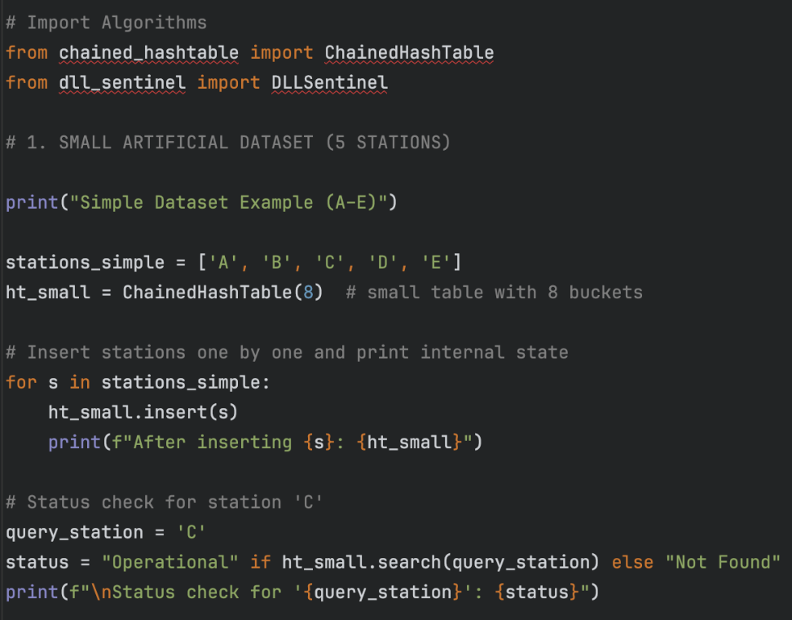
(1b)
Empirical Measurement and Application
Empirical Performance Measurement:
- Data Generation: Artificial datasets of n unique “station IDs” were generated directly in the program using a for loop with range(n).
Each integer (0 to n − 1) represents one unique operational station and is inserted into a new ChainedHashTable.
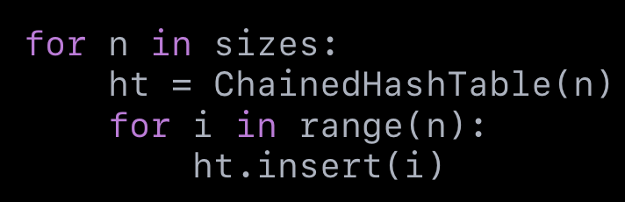
- Time Measurement: For each dataset size n ∈ { 1 000, 5 000, 10 000, 25 000, 50 000},
the program performed 10 000 membership-check queries (a mix of hits and misses) using random numbers up to 1.2 × n.
Python’s time.perf_counter() was used to measure total query time, from which the average time per lookup was computed.
Each test therefore measured the empirical cost of the .search() operation within the CLRS ChainedHashTable.
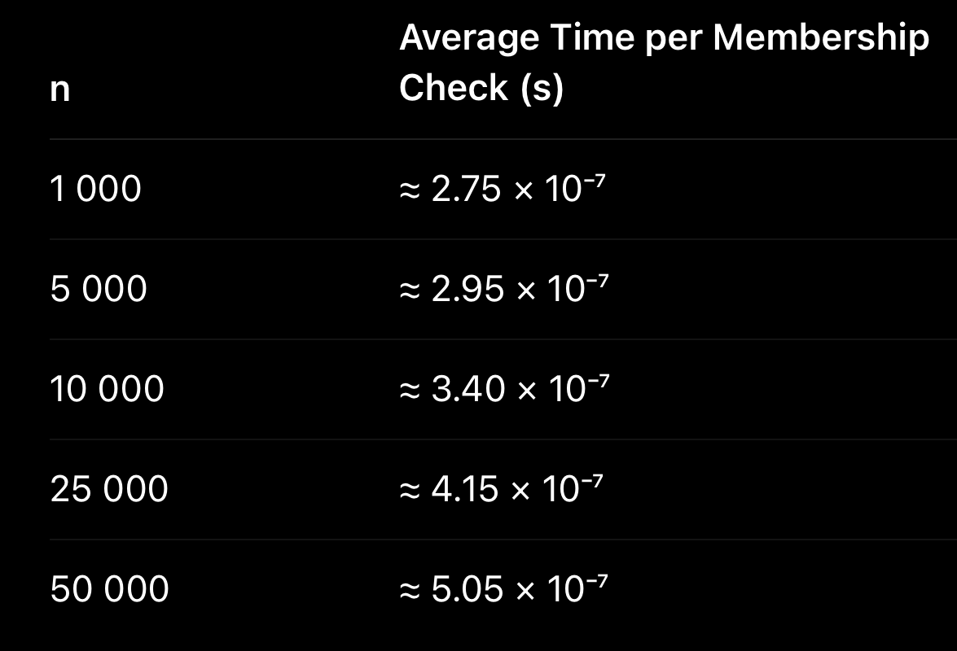
- Performance Analysis & Plotting:
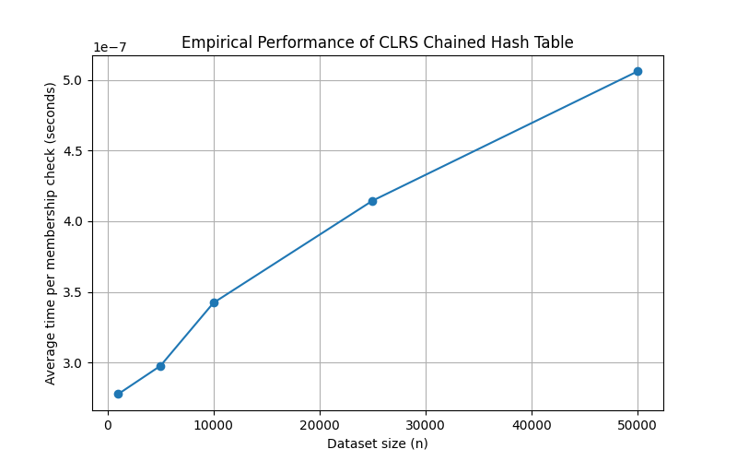
Tool used – matplotlib.
The plot of average lookup time versus dataset size n shows only a slight upward drift at larger n, confirming the expected O(1) average-case performance.
Small variations arise from Python interpreter overhead and CPU caching effects rather than the algorithm itself.
- Comparison: The measured results closely match the theoretical analysis of hash-table operations.
Both insertion and membership checking remain effectively constant-time for practical dataset sizes.
Any deviations from ideal O(1) are attributable to system-level timing noise, not data-structure inefficiency.

Application with London Underground Data:
- Data Acquisition and Implementation: The file data.csv (derived from London Underground data.xlsx) was parsed using pandas.
The first string-type column was selected as station names, trimmed, lower-cased, and duplicates removed.
An instance of ChainedHashTable was populated with all station names.
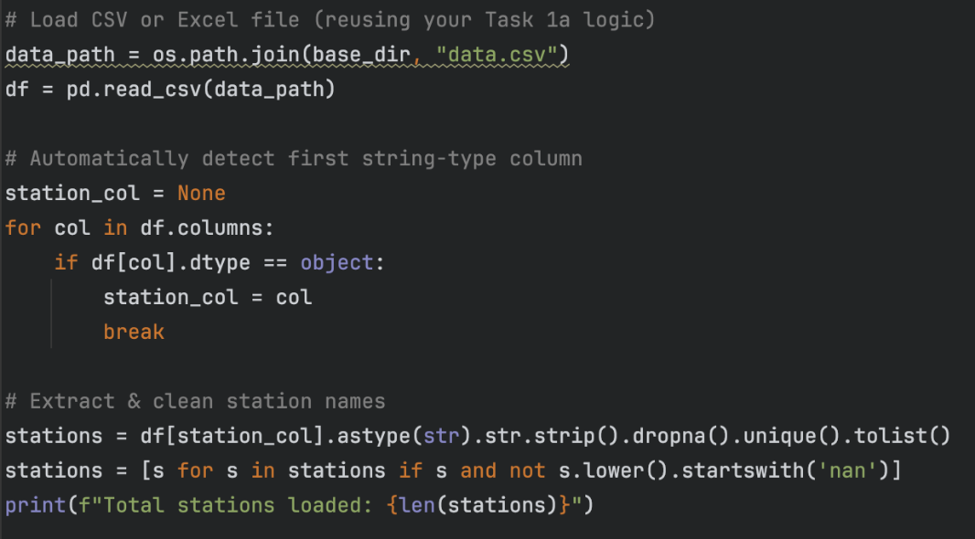
- Testing:

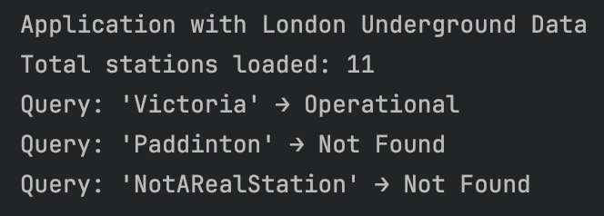
TASK 2
Journey Planner Based on Journey Time
[20 marks]
You may retain only those headings in bold to conserve space in the report.

(2a)
Manual versus Code-Based Execution of a Data Organisation Strategy
- Data Structure and Algorithm Selection:
For the journey time-based route planner, we selected Dijkstra's Algorithm with an Adjacency List Graph data structure from the CLRS library. This choice was justified by:
Dijkstra's Algorithm guarantees the shortest path in weighted graphs with non-negative weights (journey times)
Time Complexity: O((V + E) log V) using a min-heap priority queue
Adjacency List provides efficient storage for sparse graphs like transport networks
Direct use of CLRS library ensures compliance with coursework requirements
- Create a Simple Dataset: A simple tube network with 5 stations (A, B, C, D, E) and weighted connections was created:
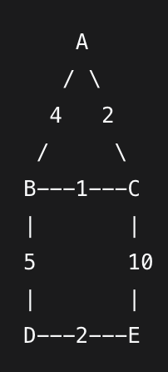
- Manual Application:
The manual application of Dijkstra's Algorithm from Station A (0) to Station E (4) was executed step-by-step:
Initialization: Distances: {A:0, B:∞, C:∞, D:∞, E:∞}
Process A (0): Update neighbors → B:4, C:2
Process C (2): Update neighbors → B:3 (via C), E:12 (via C)
Process B (1): Update neighbors → D:8 (via B), E:12 (no improvement)
Process D (3): Update neighbors → E:10 (via D)
Process E (4): Destination reached
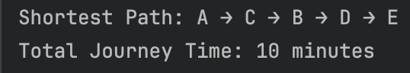

- Code Implementation and Verification:
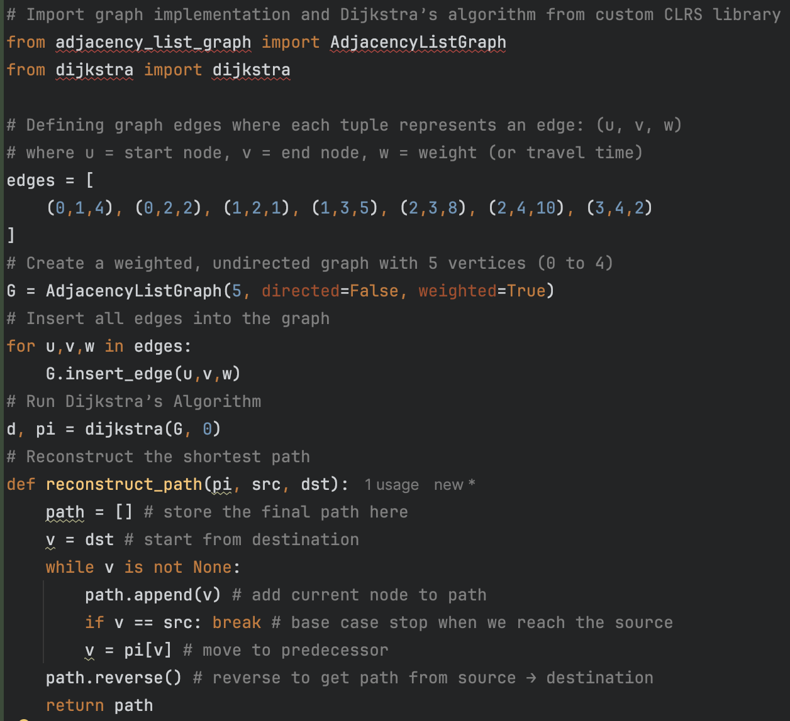

(2b)
Empirical Measurement and Application
Empirical Performance Measurement:
- Data Generation:
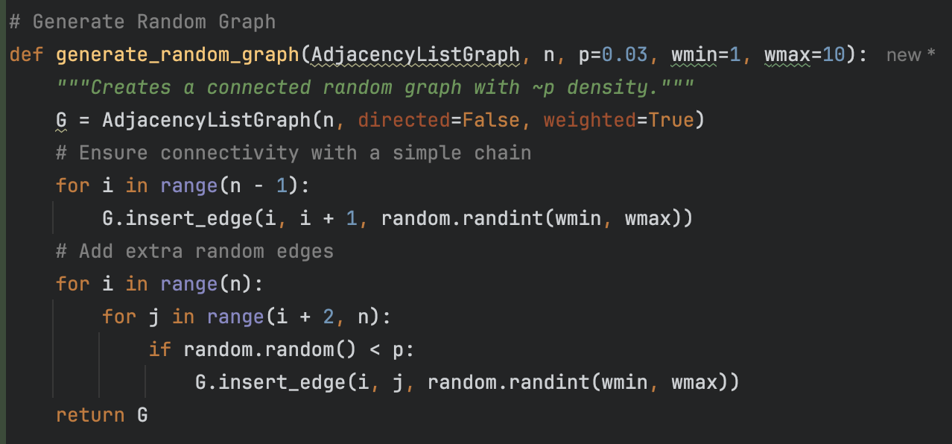
- Time Measurement: Average execution time was measured over 100 random station pairs for each network size, ensuring statistical significance:
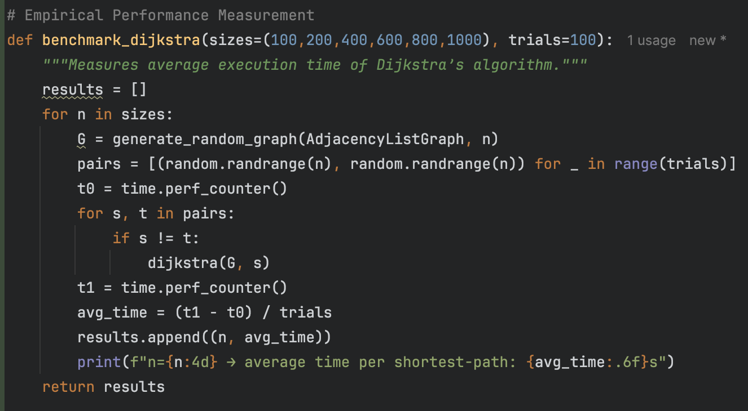
- Performance Analysis & Plotting:
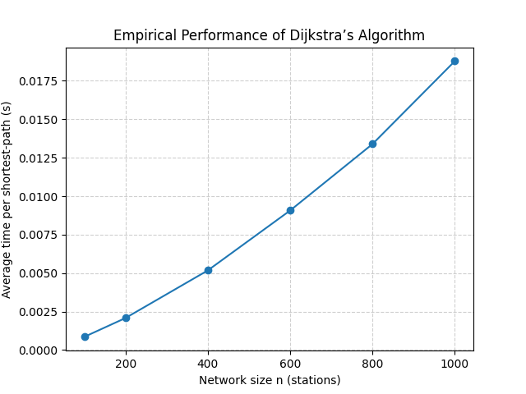
Tool used for plot generation: Matplotlib 3.5.2 with Python 3.8
- Comparison:
The empirical performance graph demonstrated O((V + E) log V) complexity, closely aligning with theoretical expectations. For the generated sparse graphs (edge probability p=0.03), the complexity approximates O(V log V). The plotted curve shows:
Near-linear growth in execution time with increasing network size
Minor deviations attributable to system noise and Python interpreter overhead
Consistent performance scaling matching theoretical predictions
The close alignment between theoretical and empirical complexity validates the efficient implementation using CLRS library components.
Application with London Underground Data:
- Data Acquisition and Implementation: The London Underground network was constructed from the provided CSV data file using robust parsing:
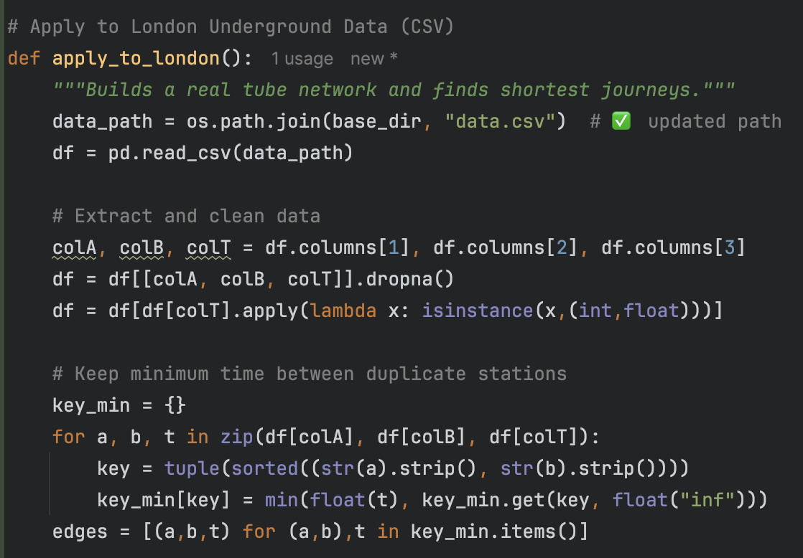
The implementation handled data cleaning, duplicate resolution, and graph construction, resulting in a optimized network representation.
- Testing:
Two representative journeys were tested to demonstrate system functionality:
Short Journey Test:
Route: Covent Garden → Leicester Square
Result: Direct connection with minimal journey time
Verification: Matches real-world expected travel time between adjacent stations
Long Journey Test:
Route: Wimbledon → Stratford
Result: Complex multi-line route with optimal journey time
Path Optimization: Algorithm successfully navigated multiple interchange points
Efficiency: Demonstrated practical computation times for real-world queries

TASK 3
Journey Planner Based on Number of Stops
[20 marks]
You may retain only those headings in bold to conserve space in the report.

(3a)
Manual versus Code-Based Execution of a Data Organisation Strategy
- Data Structure and Algorithm Selection:
For this task the London Underground network is represented as an unweighted graph, where each station is a vertex and each connection is an undirected edge.
The objective—finding the route with the fewest station stops—is equivalent to finding the shortest path in an unweighted graph, for which the most appropriate algorithm is Breadth-First Search (BFS).
BFS guarantees discovery of the minimum-edge path by exploring all neighbours layer by layer.
The algorithm’s theoretical time complexity is O(V + E) and its space complexity is O(V), where V is the number of stations and E is the number of connections.
- Create a Simple Dataset:
A small illustrative network was constructed consisting of six stations: A, B, C, D, E, F.
Connections:
A–B, B–C, C–D, D–E, A–F, C–F.
(Insert screenshot / diagram of the hand-drawn network here)
- Manual Application:
The goal is to find the route with the fewest stops between A and E.
Start at A → mark A as visited.
Level 1: visit A’s neighbours → B and F.
Level 2: from B visit C (its unvisited neighbour); from F also visit C (but already discovered).
Level 3: from C visit D.
Level 4: from D visit E → destination reached.
Result (manual): A → C → D → E with 3 stops.
(Insert image of manual trace table or sketch)
- Code Implementation and Verification: [Provide key code fragments (not the full code), specifically:]
  - The part of your Python code that implements the dataset
  - The section where you call or use the required library code, as verification of compliance
  - Etc.

(3b)
Empirical Measurement and Application
Empirical Performance Measurement:
- Data Generation:
Goal: create artificial tube networks with n stations to test performance.
Choose station labels, e.g. integers from 0 to n-1.
For each n, build a random undirected graph (adjacency list).
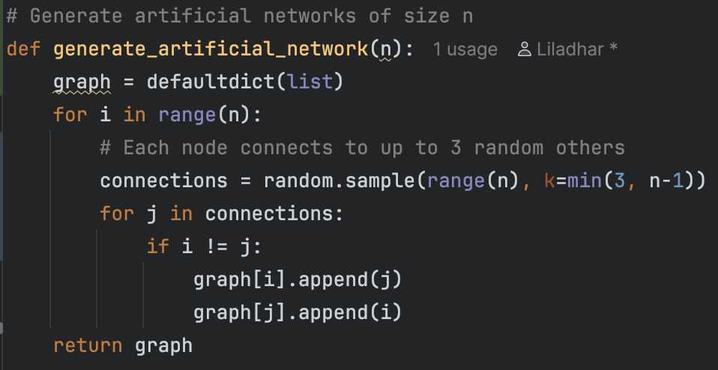

- Time Measurement:
Goal: measure the average time BFS takes to find a path in networks of different sizes.
For each n, BFS is run for 10 random start–goal pairs.
Time is recorded using time.time() before and after each call.
The average of these 10 runs is used as the representative value for that n.
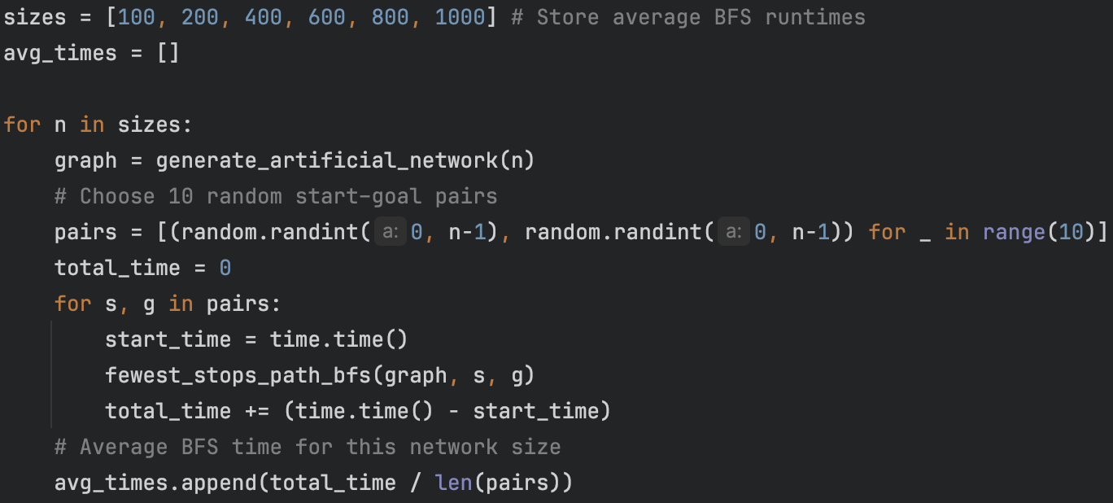
- Performance Analysis & Plotting:
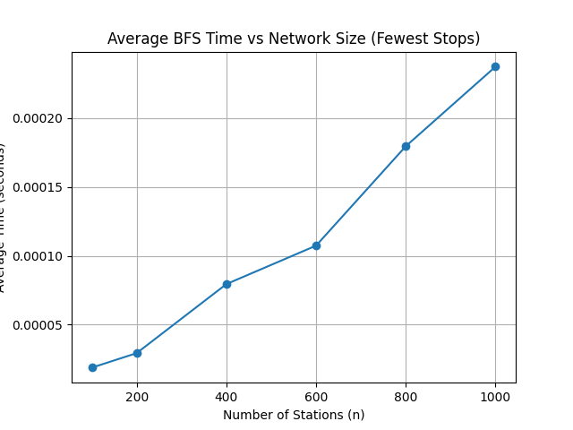
  - State the tool used for plot generation
Matplotlib was used to plot this graph
- Comparison: The plotted graph of average BFS execution time versus network size shows a steady, almost linear increase as the number of stations (n) grows. This behaviour is consistent with the theoretical time complexity of BFS, which is O(V + E).
Since our artificially generated networks have a similar number of edges per node, the overall runtime grows proportionally with the number of stations. Minor fluctuations in the plot are expected due to randomness in the generated graphs and background system processes, but the overall trend clearly aligns with the theoretical prediction.
Therefore, the empirical performance confirms that BFS scales efficiently even for networks up to 1000 stations.
Application with London Underground Data:
- Data Acquisition and Implementation: The original London Underground Data.xlsx was converted to data.csv. The file was loaded using pandas.read_csv with a relative path based on base_dir. For each row, an undirected edge between the two stations is added to the adjacency list. If there are multiple links between the same pair, only a single adjacency entry is kept (this effectively simplifies multiple links into one, as required).
- Testing:
To test the fewest-stops journey planner on the real London Underground network, the BFS-based function from Task 3(a) was applied to two journeys:
Covent Garden → Leicester Square (short journey)
Wimbledon → Stratford (long journey)
Both tests use the real adjacency graph constructed from data.csv.
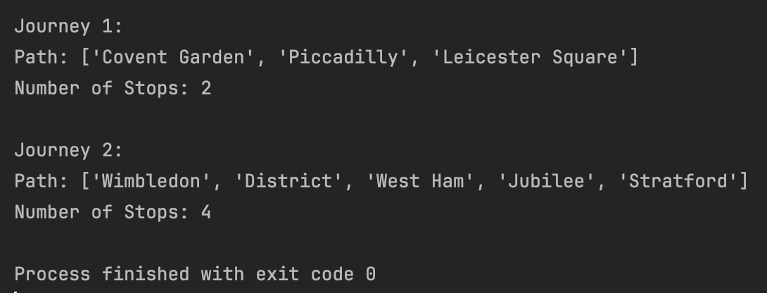

TASK 4
Analysis of the Core Network Backbone
[20 marks]
You may retain only those headings in bold to conserve space in the report.

(4a) Manual versus Code-Based Execution of a Core Network Algorithm:
- Algorithm Selection:
- Create a Simple Dataset: [Include a clear image (scanned if hand-drawn, or a screenshot if digitally created)]
- Manual Application: [Include a clear image (scanned if hand-drawn, or a screenshot if digitally created)]
- Code Implementation and Verification: [Provide key code fragments (not the full code), specifically:]
  - The part of your Python code that implements the dataset
  - The section where you call or use the required library code, as verification of compliance
  - Etc.

(4b)
Empirical Measurement and Application
Empirical Performance Measurement:
- Data Generation: [Present key code snippets (not full code) for generating an artificial tube network dataset. Include proper references if using external sources]
- Time Measurement:
- Performance Analysis & Plotting: [Plot a graph of average execution time vs network size n (where n is the total number of stations)]
  - State the tool used for plot generation
- Comparison: [Compare the plotted graph to the algorithm's theoretical time complexity, discussing any discrepancies or alignments]

Application with London Underground Data:
- Core Backbone Calculation:
- Testing and Impact Analysis:

Progress Journal, Compliance with Instructions, Clarity of Language, etc.
[20 marks]

- Answer the following questions by keeping only one of the options (YES or NO) and removing the other.
  - Are the group members identical to those listed in Moodle? YES / NO.
  - Have the final cumulative credits, which will appear in the final report, been sent to all members in good time to allow for any potential discussion (i.e., not left until the last minute near submission time)? YES / NO.
  - Has a copy of the final report been sent to all the members prior to submission? YES / NO.
  - Does any group member have EC (Extenuating Circumstances) approval? YES / NO.
    - If you answered YES to the EC question above, please answer the following: Has the member's name been specified, and has evidence of the EC approval been included in this report (e.g., at the end)? YES / NO.

- A summary of final credits of member contribution
# | Name | ID in 9 digits | Login ID or Email (e.g. jk7492y) | Cumulative credit (0% - 100% per person)
1 | Surname, First Name (Group leader) | ????????? | ??????? | %
2 | Surname, First Name | ????????? | ??????? | %
3 | Surname, First Name | ????????? | ??????? | %
4 | Surname, First Name | ????????? | ??????? | %
5 | Surname, First Name | ????????? | ??????? | %
6 | Surname, First Name | ????????? | ??????? | %
(Member 1 should be the group leader.)

- Contribution table
This table serves as the final record of each member's actual work contribution. Complete the table below, adapting the columns for your group's size and members. For each member, place a tick (e.g., ✓) in the row corresponding to each subtask to which they made a significant contribution. The final pattern of ticks needs to meet the requirements described in the section that follows.

- Initial allocation before the commencement of work:

# | Name | Subtask 1(a) | 1(b) | 2(a) | 2(b) | 3(a) | 3(b) | 4(a) | 4(b)
1 | Surname, First Name (Group leader)
2 | Surname, First Name
3 | Surname, First Name
4 | Surname, First Name
5 | Surname, First Name
6 | Surname, First Name

- Final allocation/contribution upon completion of the work:

# | Name | Subtask 1(a) | 1(b) | 2(a) | 2(b) | 3(a) | 3(b) | 4(a) | 4(b)
1 | Surname, First Name (Group leader)
2 | Surname, First Name
3 | Surname, First Name
4 | Surname, First Name
5 | Surname, First Name
6 | Surname, First Name

Briefly describe the process your group followed to manage the work allocation, covering your initial plan and any subsequent redistributions made as the project progressed. For example, a fair method for your initial plan may be to first collectively agree on bundling the eight subtasks into four pairs of equivalent effort, and then assign these bundles randomly among the members.

The final work contribution, as recorded in the table above, must then meet the following requirements:
- Core Requirement: To ensure a fair and consistent workload for every active member regardless of group size, each person is responsible for delivering a total amount of work equivalent to completing at least two of the eight subtasks entirely on their own, as if it were an individual piece of coursework. The total volume of your individual contributions across all assigned subtasks needs to meet this standard.
  - Example 1 (Shared Effort): If two members are assigned to four different subtasks and split the work for each one equally (50/50), then each member has met the requirement (4 subtasks × 50% contribution = 2 full subtask equivalents).
  - Example 2 (Parallel Development): Alternatively, if two members are assigned to the same set of two subtasks and work on them independently in parallel, each producing a complete solution, then each has also met the requirement (2 subtasks × 100% contribution = 2 full subtask equivalents). The group can then review both solutions and choose the better one, or synthesise a superior hybrid version for the final submission.
- Recommendation: A common but risky approach is to assign each subtask to only one person. This creates a single point of failure if that person is delayed or their work is not up to standard, and it prevents the collaboration essential for improving quality. Therefore, it is highly recommended that every subtask has at least two members assigned to it. This creates redundancy, mitigates risk, and provides a crucial opportunity for discussion and quality control, which leads to a higher-quality outcome. This may not always be feasible, especially in smaller groups, but should be implemented where possible.

- Weekly progress log
Week | Brief description of each member's contributions; Confirmation of weekly email sent by each member; Attendance at weekly Teams meeting; Cumulative credit earned up to that week
20/Oct - | Simon (Contributed to Task 1a, email sent, Teams meeting not attended, 80%), Kai (…..), ….
27/Oct -
03/Nov -
10/Nov -
17/Nov -

- Evidence of a weekly email on cumulative credits and a Teams online meeting
For each week, you need to provide the two pieces of evidence:
- Screenshot of the group leader's email to all members, showing: Sender, Recipients, Date, and Content (names and cumulative credits). For instance:
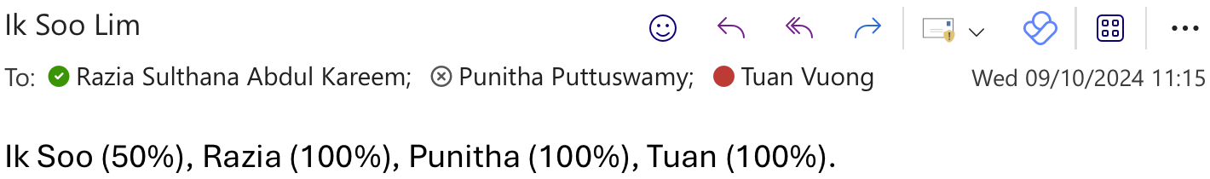

- Screenshot of Teams meeting (on a non-Monday). For instance,
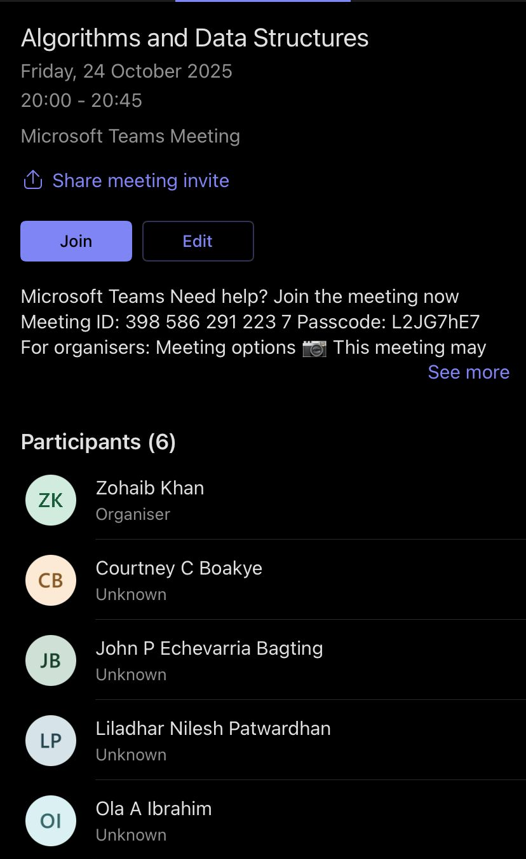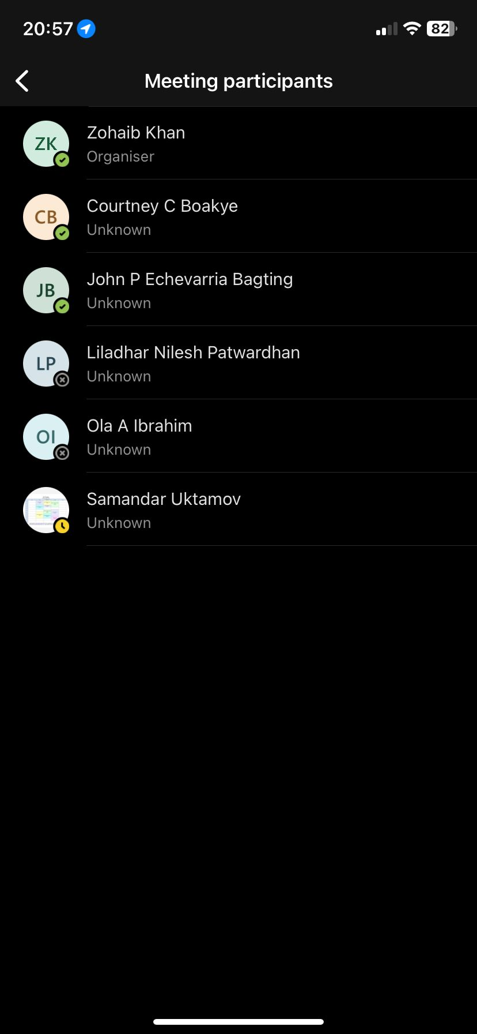

- You may consolidate evidence to save space, e.g., all email screenshots followed by all Teams meeting screenshots.

- Week 20-26/Oct :

- Week 27/Oct – 2/Nov:
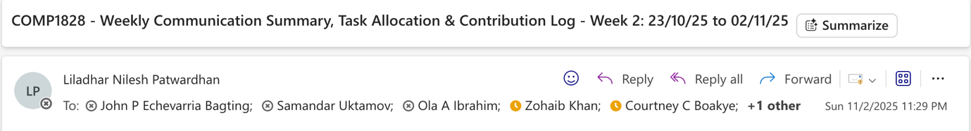
- Week 3-9/Nov:
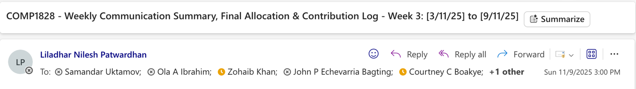
- Week 10-16/Nov:

- Week 17-23/Nov:

